Due to overwhelming response and suggestions, I figured I would comply. Today after it was found out that I was holding my TPU in my hand with hards kicks emminating from it, I was stoutly told to shield the unit and 'Don't touch the ring!'
That showed me that I had made great progress. This thread starts with those kicks that were so hard to acquire before that are now all over the place and dangerous. This thread also marks the great step into tuning. I shudder at the possibilites without safety and control.
So let us not tarry any further... for we must not look back.
Welcome to the next step of the TPU. The Ring tune. Ta-da!
--giantkiller. Please extinguish all smoking material. We don't want to encourage any unwarranted results. Any and all results gotten reflect those of management at one point or another in time.

I am listing the instructions here to wind and drive a TPU that produces kicks. Guaranteed!
A word of warning: There is a high degree of danger in doing this!
******************************************************************
The rule is: DO NOT TOUCH THE RING! when it is on. You've been warned. I accept no responsibility for your attempts at completing this project. You are at your own risk. If you follow the instructions and end up in a dangerous situation, it is your fault, not mine. I have had my dangerous moment already and it isn't pleasant.
I have gathered up the pictures of the device specifications at the bottom of this post.
******************************************************************
These instructions are the latest. This post supercedes all other posts.
Let's start off with with the coil specifications:
Coil diameter is 4", but this can vary, and consists of 3 layers of:
Collector coil is garden wire, 22 turns, standard size and there are 6" leads coming out.
Control coils are 4 segments of 30 gauge magnet wire, 200 turns in each segment.
The feedback coil is 16 gauge speaker wire (single run) wrapped around all layers in 4 segments of 17 turns.
Feedback and controls are wound using right hand rule. starting closest to you and winding over the top of the collector, down through the center, out the bottom, and back towards you, then back up to over the top following the turns to the left. Looking from the top we are traveling in a clockwise direction.
The control segments have 200 of these per segment and each turn is touching the last. There is a gap of about 1" between segments. they are proportionally spaced around the collectors.
The feedback windings are similar in their 17 turns. Each turn touches the last. There is about 1 1/4" gap between these segments.
Then interconnect the whole system by Ottos diagram shown at bottom of this post.
******************************************************************
I power the 555s with +5v and the tip41b-s with +12v. Bias resistors are 100 ohms.
Transistors like http://www.bourns.com/pdfs/tip41.pdf or equivilant.
The duty cycle resistances are 200k pots. The frequency duration resistances are 200k pots. The Tantalium capacitors range in value from .01uf to 10uf. Switch them out to suite your tests.
My settings for frequency are <200hz for all 3 555s. Vary to suite your tests.
There is only +DC pulses.
My power supply is +12v @ 8.25a
******************************************************************
Now let me be the first to lead by example. As you can see by the picture we have captured the ellusive Ring. It is safely in its cage in a quiescent state at the moment. Fear not, should it be aroused. But for safety sake let's not awaken it from it's dormant place. We are now safe. Should the creature perk up and start chattering, it is secured in a shield of containment.
******************************************************************
What I have used here is screen door aluminum cloth, formed into a block secured with duct tape. The floor is perfboard with 2 layer screen underneath. Didn't want anything shorting out.
******************************************************************
Let's talk for a moment about the sweet spot when tuning.
I used my right hand for this test. Not good! I hope the tuning fork sound will replicate the ability of feeling the sweet hit. I call it sweet for a damn good reason. The field appears in smooth layers around your hand almost like a light plasma effect. This is when you feel the temperature jump up. You feel the kicks pulsating through your flesh. It's not the heat that is the problem. It is what you don't see. It is etched indelibly in my mind, no really, headache and eye ache included. If I can get some sort of tool to catch what I felt that would be tantamount! I then have a console indicator. And with that measurement I can trip a kill switch with a visual feedback indicator automagically. I could use a heat trip but I need to balance between heat level and desired results.
******************************************************************
I worked the previous days without using any shielding and suffered a severe headache.
We are past the stage of just winding a coil and turning it on.
This stage of building means business.
I tested the cage in my weakened state and found out that I did not degrade any further. It only takes a matter of minutes to feel the effect of a closely tuned ring. My suspicion is if you feel the sweet spot on your hand, you then have achieved the headache in time. Turn the device off. Your fun is over for the time being.
Rule #1 for an active device?
Mandatory tools for this thread are a cage! The warning above still applies.
If you tune without a cage you are exposing yourself to harmful waves.
The kicks kick ass. Yours!
******************************************************************
Current Must things to do:
Replace the potentiometers with a higher quality. This will definately change the results.
Consolidate the mag wires tighter into the coil. This is to prevent breakage during portability.
Apply Thermometer to coil for temperature tests in sequence with locating the sweet spot of tuning.
Apply Amperage meter in line with PSU in sequence with locating the sweet spot of tuning.
Apply Tuning fork on coil. I'll bet you this is better than using magnets when

locating the sweet spot of tuning or cooking my hand!
I will post the results here of the Potentiometer replacement.
******************************************************************
We want your stay here to be a pleasant one.
Thank you for your participation, the management.
Troubleshooting:-
Ok, I suck at making circuits.
There are several reasons I haven't tested my almost completely build TPU (v1, GK's design) and most of it comes down to troubles with the 555 circuit, I solved most of the problems but 1 remains.
When I have any one of the 555's on it works fine, but when I turn on 2 or especially 3 they somehow interfere with each other.
Now this may be because I don't have a small value cap between pin 5 and GND, but I figured as everyone here has built this circuit, you should all know how to fix it.
So has anyone else had this problem?

Response from GK:-
A simple fact maybe I missed.
I have a highly regulated, industrial 12v supply. I pull +5v from that thru a 7805 t220 package and more capactor filtering. Then I have more capacitors at the 555s. And i repeat from somebody else, again each 555 has its own resistors and capacitors.
Don't give up! your so close. Ask questions, whenever. Somebody will pop up to the rescue! Don't be daunted by what others do. That just means they have to time to answer questions.
And don't tell yourself bad things. If you notice in this last set of postings nobody else did! You don't have that right either. Well you do, but don't.
So check this out http://thesecret.tv/home.html. A number of friends and I have been following this and the returns are phenominal. How bad do you want it?

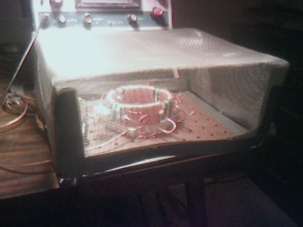

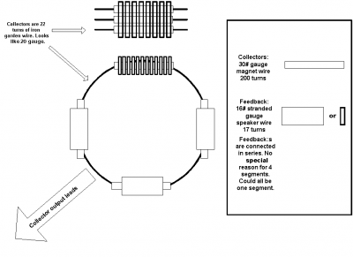

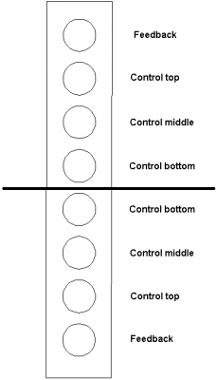

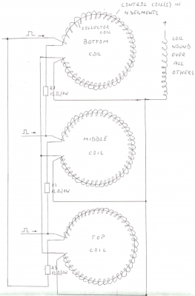

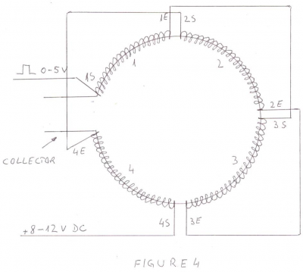

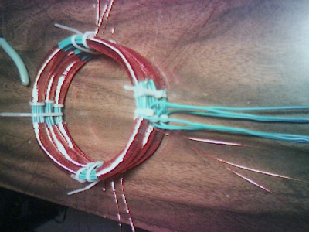

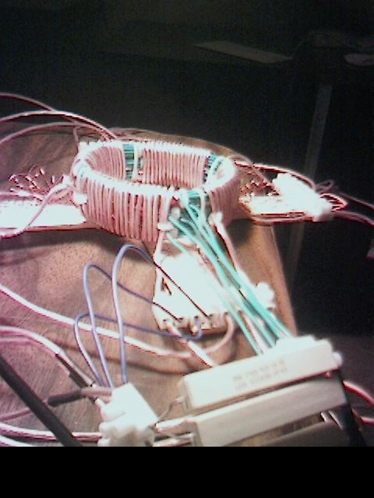

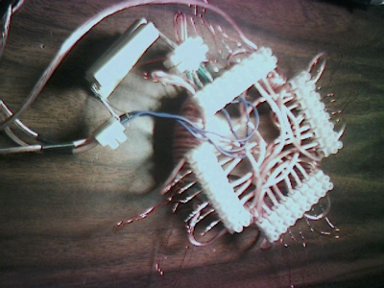

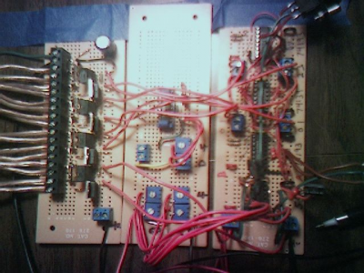

Cams cct design which is being used for driving each coil section, note the cct below is replicated 3 times, one for each coil, As per pic above, also transistors used above are tip41b-s.
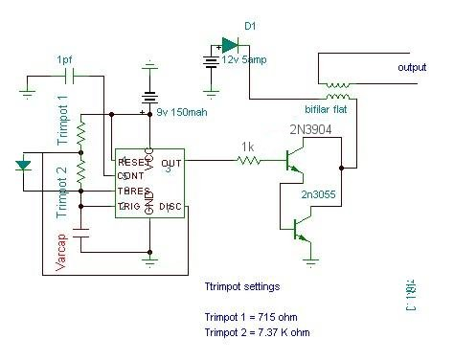
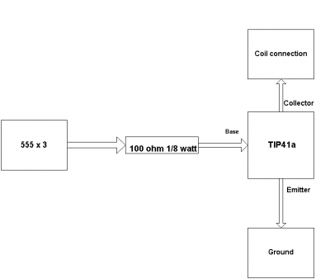

SAFETY CCT BEING USED, LOW SECTION CAN BE OMITTED:-

HIGH AND LOW VOLTAGE CUT OFF WITH TIME DELAY

Overview

The power line fluctuations and cut-offs cause damages to electrical appliances connected to the line. It is more serious in the case of domestic appliances like fridge and air conditioners. If a fridge is operated on low voltage, excessive current flows through the motor, which heats up, and get damaged.

The under/over voltage protection circuit with time delay presented here is a low cost and reliable circuit for protecting such equipments from damages. Whenever the power line is switched on it gets connected to the appliance only after a delay of a fixed time. If there is hi/low fluctuations beyond sets limits the appliance get disconnected. The system tries to connect the power back after the specific time delay, the delay being counted from the time of disconnection. If the power down time (time for which the voltage is beyond limits) is less than the delay time, the power resumes after the delay: If it is equal or more, then the power resumes directly.

This circuit has been designed, built and evaluated by me to use as a protector for my home refrigerator. This is designed around readily available semi-conductor devices such as standard bipolar medium power NPN transistor (D313/SL100/C1061), an 8-pin type 741 op-amp and NE555 timer IC. Its salient feature is that no relay hunting is employed. This draw back is commonly found in the proctors available in the market.

The complete circuit is consisting of various stages. They are: - Dual rail power supply, Reference voltage source, Voltage comparators for hi/low cut offs, Time delay stage and Relay driver stage. Lets now look at the step-by-step design details.

1. Dual rail power supply.

This is a conventional type of power supply as shown in Figure 1. The power is applied through the step-down transformer (230/12-0-12V/500mA). The DC proportional to the charging input voltage is obtained from bridge rectifier. Two electrolytics are there to bypass any spikes present. Bridge is capable of handling currents up to 1 Amp.

Output is given by: -
V(out) = 0.71 X V (secondary)
= 0.71 X 24V
= 17.04 V
(This equation is similar for the negative rail as well)

Figure 1

2. Low voltage cut off op-amp

Figure 2 shows the use of very common and easily available op-amp 741 as a comparator. The op-amp is available in TO-5 and DIP type packing.

Figure 2

In this ckt the zener diode D1 and it’s associated resistor R1 are connected to the non-inverting terminal (+ve) of 741 to give the suitable reference voltage. The DC voltage from the sensor is given to the inverting (-ve) terminal through pre-set R2.This is used to set the input level.

When the sensor input is less than Zener voltage the output from the Op-amp remains high and when it is greater than Zener voltage the output goes low. When the sensing voltage is equal to Zener voltage the output of the op-amp is approximately zero.

This phenomenon is used as a decision for switching the relay and to give cutoff in a low voltage situation.

3.High voltage cut off op-amp

Here the op-amp is used as a inverted amplifier. See Figure 3.Zener and resistor network gives reference voltage to the inverting terminal (-ve) of op-amp. Sensing voltage derived through the 10 K pre-set is given to the non- inverting (+ve) terminal and this sets the high level cut.

When the input DC from the sensor is less than Zener voltage the output of the op-amp is low and vice-versa. When the input DC voltage is equal to the zener voltage, the op-amps output is approximately zero.

Figure 3

4. Time delay
I’ve selected the 555 timer due to following reasons.

- Timing from microseconds through hours.
- Ability to operate from wide range of supply voltages.
- High temperature stability.
- Easily Available.
- Its triggering circuit is quite sensitive.

This is basically a monostable. The external timing capacitor C2 is held initially discharged by the timer. The circuit triggers upon receiving a pulse to its pin 2 when the level reaches 1/3 Vcc. Once triggered., the circuit will remain in that state until the set time is elapsed or power to the circuit cuts off. The delayed period in seconds is 1.1 C2.R1 where R1 is in megohms and C2 is in microfarads. In practice, R1 should not exceed 20 M. If you use an electrolytic capacitor for C2, select a unit for low leakage. The time delay may have to be adjusted by varying R1 to compensate for the wide tolerance of electrolytics.

Figure 4

5.Relay Driver

The output from the voltage level detectors cannot directly drive the relay and hence the relay driver is used.

Figure 5.

In this a relay (12V <500 ohms) is connected to the collector of NPN transistor. The out put voltage from the comparator is applied to the base of NPN transistor through a resistance R1. When the output from the comparator is low the transistor is in OFF state and the relay is in de-energized state. Similarly when the output from the comparator goes high the transistor switches ON and the flow of current from the collector to emitter of transistor energizes the relay.

Generally in a relay driver circuit, parallel to the relay coil, a diode or a capacitor is used. This is to eliminate the back e.m.f generated by the relay coil when currents are suddenly broken. Capacitor C1 is connected in parallel to the coil, which filters out the back emf but it, slows down the working of relay.

A better method is to connect two diodes (as shown in the figure 5) that stop the relay – transistor junction swinging more than 600mV above the positive rail or below the zero-volt rail. During normal operation the diodes are reverse biased and have no effect on the performance of circuit. But when back emf is induced, the diodes conduct heavily and absorb all transient voltages. However, I have employed the both methods.

6. The Complete Circuit

Figure 6

Once you assemble all the above stages, the final circuit looks like in the Figure 6. I have not shown the power supply for the clarity. The two Op-Amps U1A and U1B are used for low (minimum) voltage and high (maximum) voltage comparators respectively. The zener diode D3 (9.1V) is used to supply the reference (constant) voltage. The Op-Amp U1A operates as inverting amplifier and U1B operate as non-inverting amplifier.

The reference voltage from zener is applied to the +ve terminal of Op-Amp U1A and to the –ve terminal of Op-Amp U1B. The low voltage limit set by the pre-set R8 is applied to the –ve pin of U1A and the high voltage limit set by R9 is applied to +ve terminal of Op-Amp U1B.

Under normal operating conditions i.e. when the input voltage is between maximum and minimum limit the output from the both the comparators are low. The transistor Q1 is OFF and the relay is in de-energized (pole connected to N/C pin) state and the output is obtained.

When the input voltage is below or above the limits set by the pre-sets R8 or R9, the output of the Op-Amps goes either low or high and diodes D1 or D2 would be forward biased depending on the situation. Transistor Q1 switches ON and the flow of current from collector to emitter energizes the relay and the output is cutoff.

A small amount of hystersis has been added via feed back resistors R10 & R11 so that the relay turns on when the level falls to a particular value but does not turn again until it raises a substantial amount above this value. Other wise the relay contacts will frequently turn on/off and produce chattering.

Construction Hints

1) I used a piece of varoboard, which has copper strips on one side to mount the components, and housed the entire circuit and the transformer in a discarded ATX PC power supply box.

2) An autotransformer has been used to set the limits. Set the output of the autotransformer to 250V AC and connect it to the primary of transformer T1 (see Figure 1). Then adjust the pre-set R9 such that relay just energizes. This is the high limit. Next set the output of the autotransformer to 200V AC and adjust the pre-set R8 such that the relay energizes. Please note that these are my preferred limits but you may select any range from say 170 to 270V AC.

3) A neon with a suitable resistor could be connected between the AC supply lines as an ON indicator. Alternatively, LED with a current limiting resistor could be connected between the relay coil so when the relay is energized LED will indicate the situation.

Disclaimer

Please take the greatest of care in handling AC mains supply while constructing this project. If you have no knowledge of mains wiring or unfamiliar with household mains supply, PLEASE DO NOT ATTEMPT CONSTRUCTION. I take no responsibility in any personal injury or loss of life or properties suffered by any person while undertaking the construction of this project or using the end product by following my instructions.

TESL:AS PATENT, USED IN OTTOS TPU

