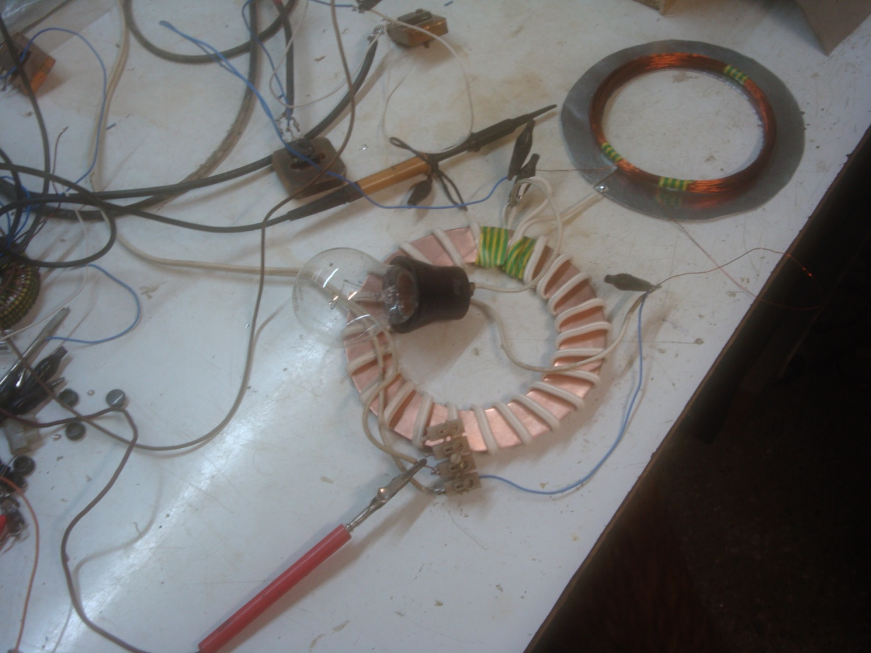This is a report about how Im building a open version of a TPU. I have to say that this work is based on my knowledge and I didnt get any help from the inventor or somebody else.

- How it started

after over 2 years of a lot of tries, after over 150 builded TPUs I had the feeling that something was wrong! But where was the failure? I was thinking about this problem days and nights but...

I tried to build the TPU in all possible ways and as all the people arround me in the forum, no success! No, I was never frustrated but wasnt it a little bit strange? Over 2 years and nobody made it? Its clear that Im not the "brightest lamp" in the forum but.....

A time ago I made a little transformer to get a high voltage. It was clear that a TPU "needs" this high voltage so it could work in a proper way.

And it was clear that NEGATIVE PULSES ARE needed. When I made the ECD I also used negative pulses because they seemed to work better then the positive pulses.

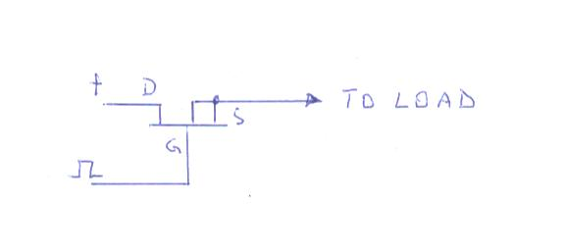

Pisture 1

This is how Im connecting a MOSFET

I made 2 of the already mentioned little transformers and connected them in all possible ways to get good results on my bulb. In series, in parallel.......I saw very big signals ......a good light, a not so good light.... but I was not satisfied! Something was wrong! But what??

You have to know that I was always surching for "something special". I didnt know what exactly to expect but...it was just a feeling that something has to "happen".

So, one day I pulsed my little transformer and saw this signals:

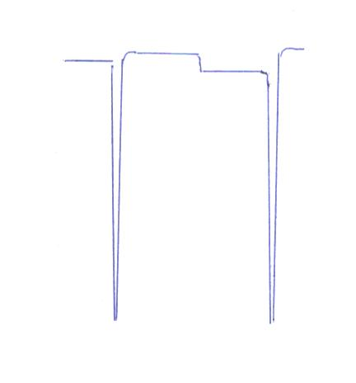

Picture 2

As you can see this are oridinary negative kicks. Nothing special!

Then I made a coil, 11 cm = around 4" in diameter and 20m long. On this coil was the scope connected. In the center was the mentioned little transformer. The primary pulsed and the secondary was not connected.

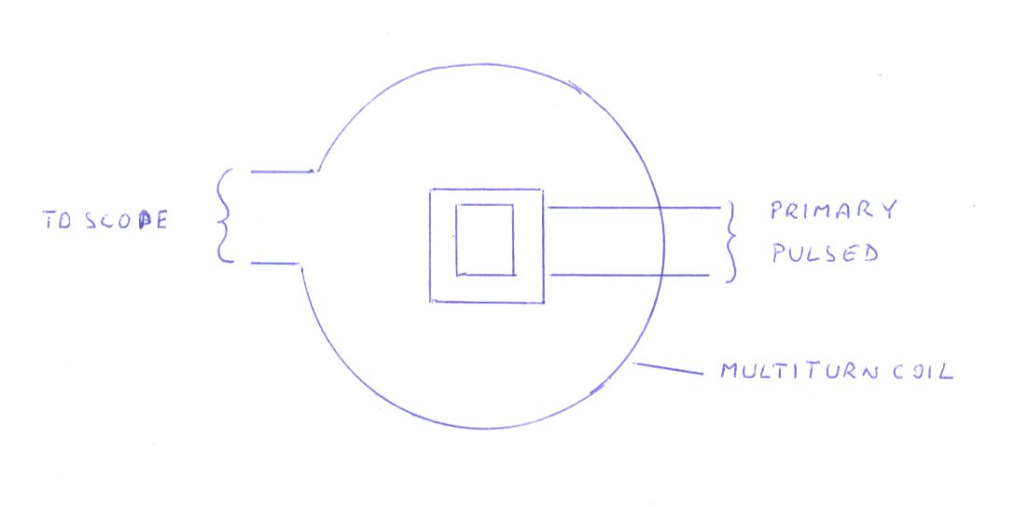
Picture 3

I saw this signals:

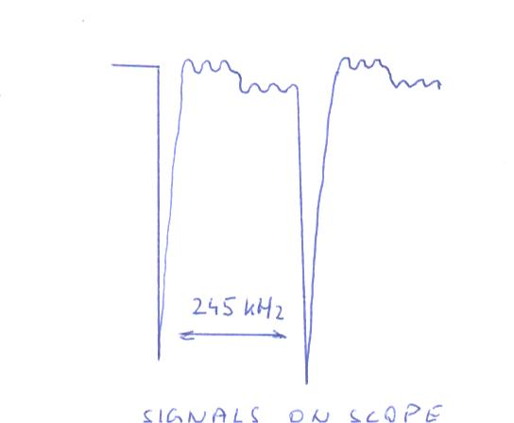

Picture 4

When I saw this signals my heart almost stopped!!! I said to myself THATS IT!!!! My God, I was in this moment the happiest man in the universe!!! I made it!!! WOOOOW!!!

You will now wonder but with this signals I saw this:

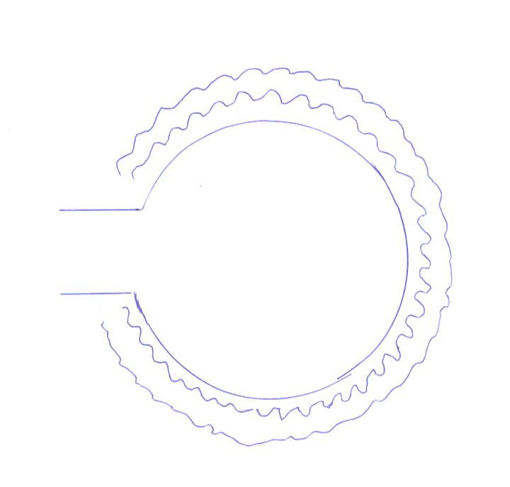
Picture 5

In the same moment as I saw the signals I saw waves all around this coil. Fantastic!

And in my imagination I saw this:

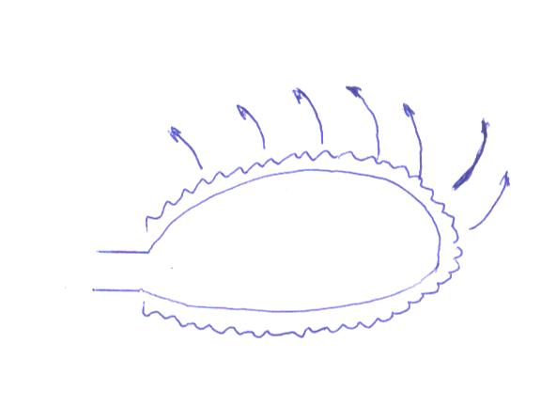

Picture 6

The near field around this coil was disturbed. I really saw in my imagination how the particles are fired in all directions.

And I saw this:
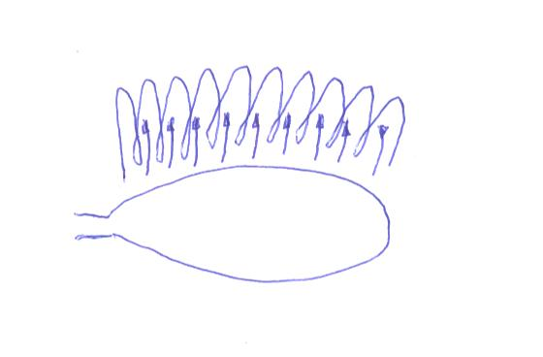

Picture 7

This all happened in less then 1 second. But hmmmm......as you see in picture 7 my imagination showed me that the picup coil has to be VERTICAL!!! Hmmmm....
This would mean that a pickup coil or as we say a COLLECTOR coil is wound in a VERTICAL way!!!

Is it possible that we messed up the terms for our coils? Is it possible that I and ALL the known and unknown TPU builders are pulsating the wrong coils and that this is the reason for our failures???

Then I made a picture for myself to better understand whats going on:

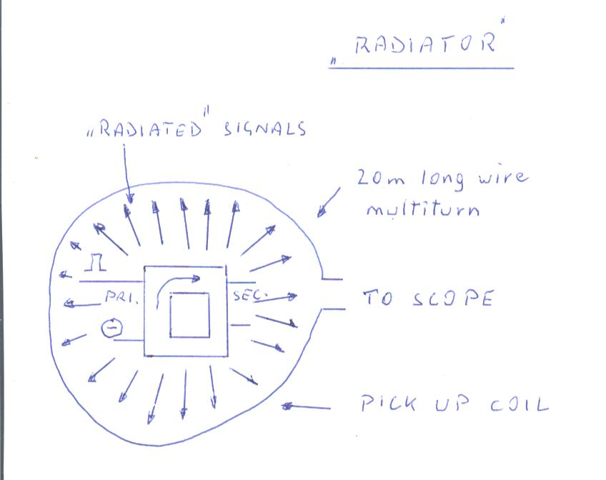

Picture 8

The little transformer was pulsed. The primary. Secondary not connected.
Every single pulse that hitted the little transformer, hitted also the multiturn coil around this little transformer but hitted also everything near the pulsed coil. So, this little transformer with his not worth to mention squared surface did a great job as a radiator of PARTICLES!!!! Yes, particles were fired into the surrounding of this little transformer. This particles.....very dangerous!!!! I thought I would die after hours and hours pulsating this little "nothing"!!! I felt sooooo bad.

When I made the little transformer and I was sattisfied how it worked I wanted to build a bigger in the same manner and in the hope to get something "usefull". I made a lot of bigger transformers but I was wrong. They didnt work better.

How to "translate" my little transformer into something bigger like we could see in the video of a 6" TPU??

6". This looked like a dream but how to do it?

In my garage I found a metal plate 1 mm thick. It was a Zinc coated iron plate. As I didnt had nothing better, I made 2 cores: 6" outer diameter and 4" inner diameter. One end open.

The collector I made with a lamp wire and wound it around a copper core cutted in the same manner as the iron – zinc core:6" outer diameter and 4" inner diameter., 22 turns.
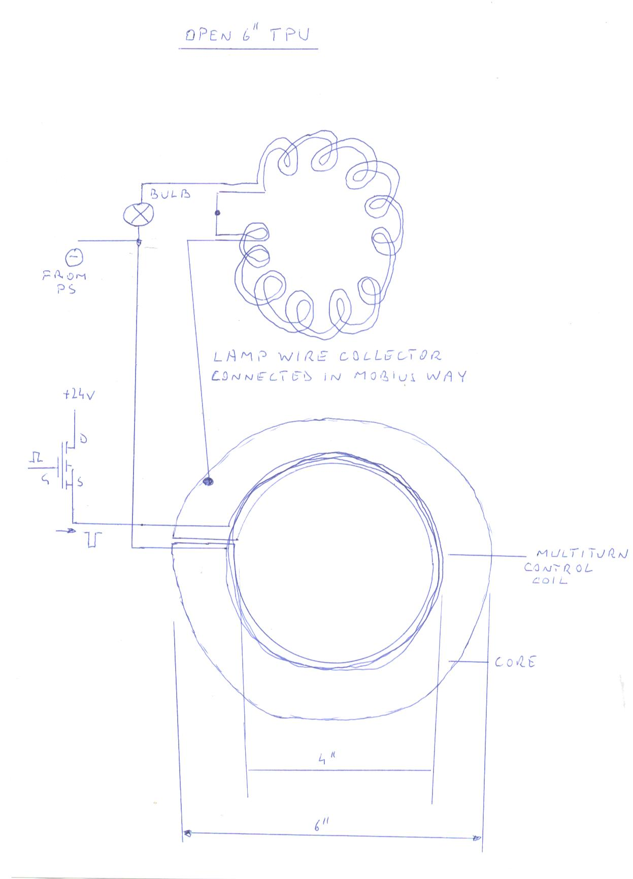
Picture 9

As shown in the picture I have my setup connected as shown.

The idea was to knock out particles from a metal core. This was the last possible solution to build a TPU. A very long time I wrote to a friend that I see a TPU as a "vacuum tube" without a vacuum. So, a metal has to be heated and in such a case the metal would release particles that are collected with the collector coil.

I WAS ON THE RIGHT PATH!!

I saw this signals. With such signals I have a nice light.

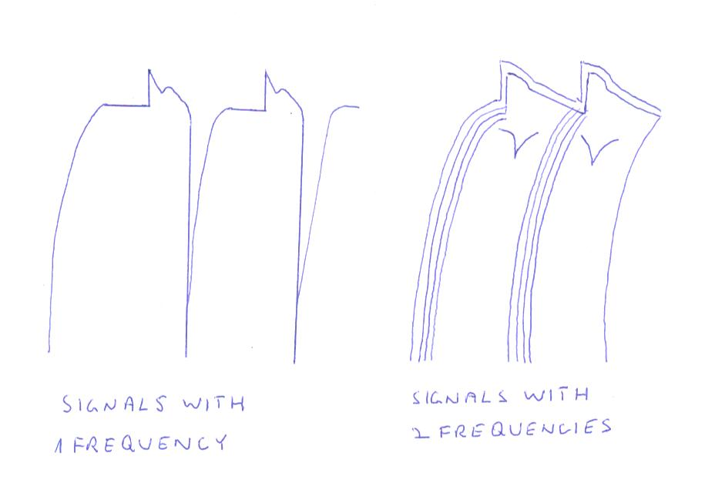

Picture 10

I used 2 frequencies to pulse this setup. What I saw was really unexpected!!

This coil produced a high voltage!!
This coil produced vibrations!!

I had to find out what was going on!

As I almost always have to use wires that I used several times, I saw an arcing between the coil and the core and so I was "clever" and placed a cork insulation between the core and the cork.

No light!! Hmmm...

Again "clever", I isolated the core with a isolation band.

Again, no light!!
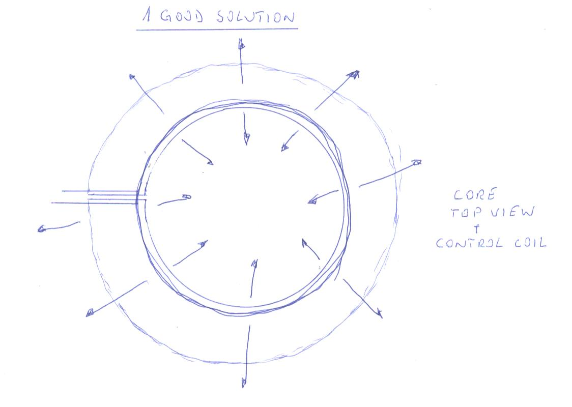

Picture 11

So, my conclusion is that when a puls is hitting the coil, particles are fired out of the core in ALL directions .

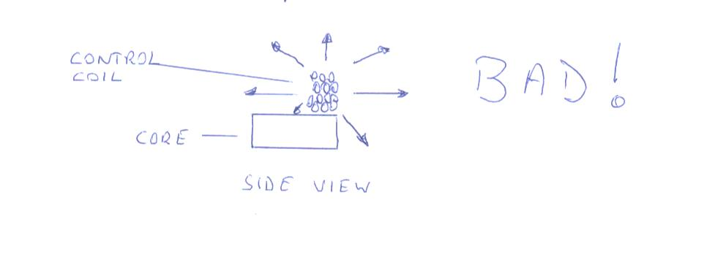

In picture 12 you see a side view of my setup. Only 30% of the core is active and the rest, as its not covered with the wires of the control coil, is not active. A very bad solution.

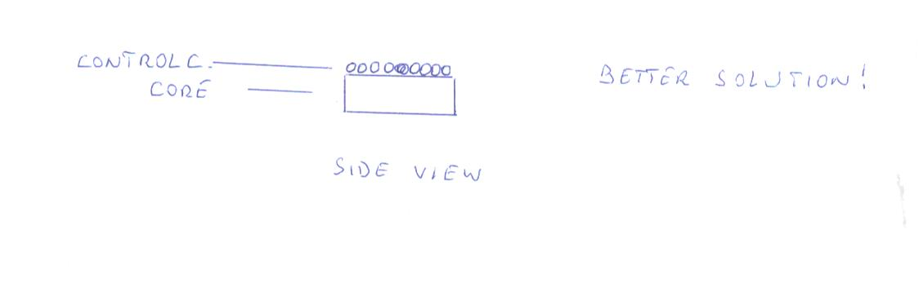
Picture 13 is again a side view of a better solution. Now all the core is activated but the problem is that only 50% of the possible particles are released and 50% are fired into the air.

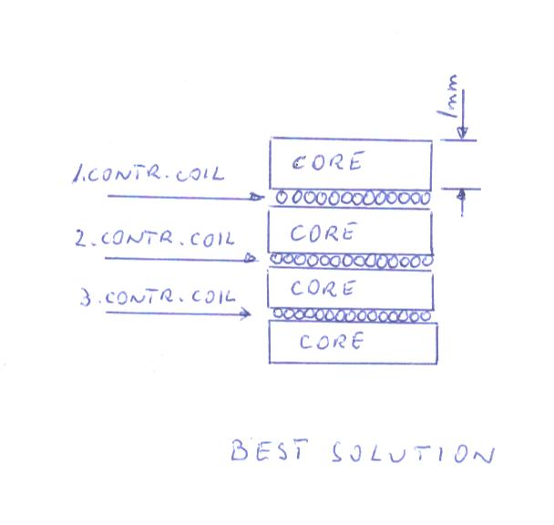
Picture 14 showes us the best possible solution. Its again a side view of the 3 cores and the control coils. 3 control coils are shown.

In my tests I had only 1 control coil and 2 cores so I made a "sandwich". 1 core on the bottom, then the control coil and another core on top.
Or in other words, the control coil between 2 cores.

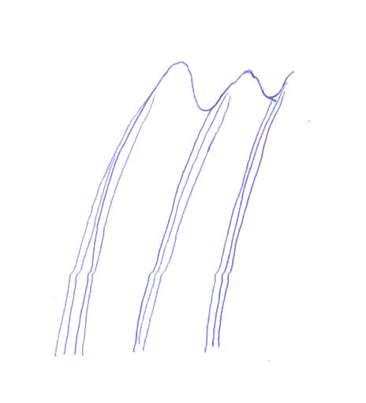
This is a very important picture in the understanding of a TPU and what we want to achieve: you can see sines and kicks.
A TPU converts kicks into sines so we can use a TPU as a source of energy.

This means, the bigger the sine waves the more output power. But there is a problem: if a TPU converts all the kicks into sines then you have a runaway. So, we need kicks + sines and the TPU is safe!!! Kicks + sines in that way that both signals have the same value or in other words, they have the same voltage.
In this picture you can see only little sines and very big kicks, in kilovolts.
Its the first time that I could measure with my cheap voltmeter 110V – 120V on my bulb. The digital voltmeter was blinking and this means that the kicks are still "disturbing" the measurement. The conversion was not worth to mention because of the used core.

- The core

The core is very important for the working properties of a TPU.

I made several copper cores. Outer diameter 6", inner diameter 4". NOT good!!
I made then aluminium cores with the same diameters. NOT good.

That are both non magnetic metals.

Then I made a zinc coated iron core. The Zinc coating was made in a chemical way.

Not bad. You see my results.

Zinc is a soft metal very good for pulsating but not to use as pure Zinc.

A much better solution is to use a zinc coated iron core but the zinc coating is made in a hot way!! In this way has the surface of the iron changed and it looks like its almost an alloy!! This is much better.

Now the best solution:

We have to get rid of the iron because its heated when pulsed or in other words, the iron resists to much to release the particles. A logic solution is to use Nickel. Nickel is magnetic like iron. Then we need a metal that has excellent properties wehn pulsed: Zinc.
And we need a metal that has all the peoperties of copper: its of course Copper.

So, in short, an alloy is needed that contains Copper, Nickel and Zinc.

The name of this alloy is:

German silver
China silver
Alpaka, Alpacca, Alpaca

A lot of names. But not an alloy that containes the mentioned metals + lead or something else. Just the 3 mentioned metals.

You all know Teslas patents. This great man used also this alloy and NOT iron cores!!
Now look at a patent where he uses a "iron core" and inside this core is a wire. Come on people. Think about my words!

- a "sepcial effect"

as mentioned, I made a horizontal coil ( control coil) 20 m long and 11 cm = 4" in diameter.
With a lot of luck I had in the same moment a fine light. 24V from the power supply and connected like in picture 9.
I had to measure the exact lenght of this coil and I measured exactly 19,50m. The I cutted this control coil and figured out that it works in the lenght 19,30m – 19,50m. More or less doesnt work!!! No way.
The I wanted to know the lenght of the collector made with a lamp wire. I used 22 turns and it s OK.
21 turns doesnt work!!
23 turns doesnt work!!

22 turns are "magic"!!

As I wanted to use all the cores surface I made a coil with a bigger diameter: it was 12cm in diameter. The idea was to place 3 coils onto the core.
1 coil 11 cm = in diameter
1 coil 12 cm = in diameter and the 3. coil again in a bigger diameter. One coil inside the next.

So, I made a control coil 12 cm in diameter. I have to mention that I always use a 0,5mm diameter for my wires.

The circumference of this coil is 37,7 cm. I made a 20m long coil and started to cut it and cutted almost all the control coil!! hmmmm...... no light.

I made again a new coil with the same lenght and again I cutted it. As I had always a lot of luck in one moment I turned this coil "up side down" and had a light!!!!
This was totally unexpected!! This coil worked only when placed up side down on the core. What a surprise!!!

But I was in a big trouble: I didnt measure how many meters and centometers I cutted my cotrol coil. So, my next job was to unwind this control coil and to measure the exact lenght of this coil.
And another trouble: I have lost the exact circumference of this coil but was able to somehow find it out.

So, I measured the lenght of this coil: exactly 16,2m

I wound again the same coil but failed a little bit in the circumference of this coil. NO light!!!
So I cutted this coil every 1 cm and tried to get the light.

Suddenly I had again a good light. The lenght of the control coil was now exactly 16,14m!!

What I want to say is that if you fail only 1 mm in the circumference of this coil you failed in the lenght of this coil in cm!!

This is the most complicated coil I ever made.

Now in short:

the control coil is now the collector
the collector is now the control coil.

So, if you look at the 3 stack picture Mannix posted a long time ago you will see something very usefull and at least, nice:

If you imagine to pulse the inner, white coils you will see that the outer blue, black.....coils can easily collect the particles fired out of this pulsed inner coils.

The 3 stack is also a perfect "shield". As the inner coils are pulsed, the particles are fired outwards to the outer, vertical coils. They pick up - collect the particles and your body cant be hitted by the particles!!! So, in this way we have a "natural" shield made with the collectors!!
Nothing is wasted in the 3 stack. Its a fantastic drawing.

Im releasing this because its time for me to buy the core metal but as Im in a big trouble with money and as I cant buy this alloy in my country I give this informations to you all so you can finnish what I started to build.

I gave you what I have in this moment. Of course I have also a theory but this is not important in this moment.

Written by

Otto Sabljaric , December 2009

