A Working Radiant Free Energy System

By Ossie Callanan – January 2007

A Working Radiant Free Energy System Introduction - By Ossie Callanan

I believe I may have this radiant energy system worked out to the point where anyone can build it and when you build it, all of it, it can provide you with free and continuous energy.

There are two sides to it and just having either side is no good, you must have both. Of course, one side is the motor/charger side, and the other is the battery and accumulator-converter side.

So far I am charging batteries with COPs from 2 to 10. Battery swapping is no problem.

A Working Radiant Free Energy System Part 1 - By Ossie Callanan

First I want to focus on the charger side of the system. Basically, you must build a charger that produces copious amounts of radiant energy or radiant pulses. Radiant energy pulses are indeed the back emf pulses themselves when they are very fast and sharp HF pulses. They are NOT transistor or switching transients! A spark gap produces classical radiant energy pulses. They are chaotic but radiant energy events never the less. Switching a coil on via a transistor very fast will produce one radiant energy pulse from the coils back emf. But one is no good. You need thousands and millions to be of any use.

John's SSG (Simplified School Girl motor) only produces a very small amount of radiant energy when you have the base of the transistor tuned so that you get the longest self oscillating pulse train per magnet pass. It is not very efficient as the base clamping diode wastes this energy back through the base resistance/bulb/lamp but it is necessary to allow you to tune and provide a driving force to the passing magnet. Without the base clamping diode, you get an oscillator and the motor won't turn, catch 22.

But still, even when tuned with the base clamping diode, the self oscillating pulse train is usually at most 3-6 pulses which are not much and so, not much radiant energy. For all those people trying to tune the motor for only one pulse per magnet pass, they are wasting their time and only building a pulse motor and not an efficient radiant energy generator.

In short, the SSG is not a very powerful or good radiant energy generator and apart from being educational, it is really a waste of time unless someone can explain to you how to tune it for the most radiant energy with a long pulse train and then tell you what to do with the radiant energy. John's method of using a bulb/lamp in the base is to keep the motor tuned to a particular number of pulses in the pulse train per magnet pass or for the longest pulse train as the motor increases speed and the battery's impedance changes the speed as well. The bifilar coil (one coil used just for trigger) and the waste in the base circuit add to the inefficiency and makes construction more difficult.

In saying that about the SSG I would like to show you now a very simple and basic pulse oscillator or motor driver circuit that you can build with off the shelf parts and that will produce copious amounts of radiant energy when adjusted correctly. Here is the circuit.

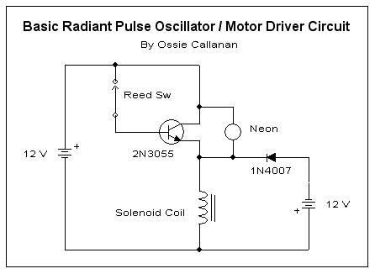

Do not be fooled by appearances! This is as close to a controlled spark gap circuit as you are going to get and extremely efficient in the production of radiant energy! But most importantly, you must place and adjust the reed switch appropriately and properly!!! Take a look at this picture.

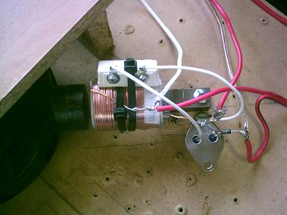

As you can see, the trick is to place the reed switch so that it is axially parallel to the coil and in the coil's field. This couples the coil's field to the reed switch and the passing magnet's field. This provides a magnetic feedback and turns it into an oscillator. So when the magnet passes the reed oscillates with the coil's field and causes very many pulses like 20-50 pulses per magnet pass. Amazingly, unlike the clamping diodes in the SSG, this is not wasteful. This reed oscillation actually reduces the current input as you can understand. Instead of the reed remaining on for the pulse duration, it is turning on and off so as a consequence less input power is required. I run the motor such that when the coil is energised, the magnet is attracted to the coil. Here is a trace across the charging battery.

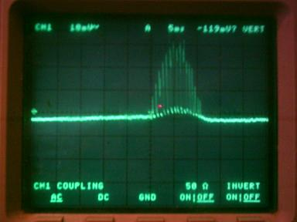

The trace above is from a motor that is only drawing 50ma but is charging the battery many times faster than if it was drawing 300ma with single pulses per magnet pass! But there is more. Take a look at the following picture.

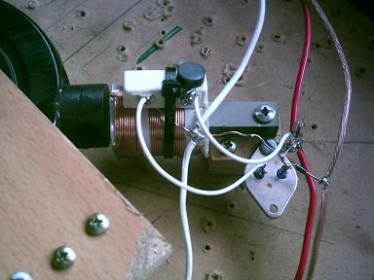

Using a very small and weak magnet, you can now control and adjust the reed switch. This will now allow you to adjust the switching so that the circuit oscillates continuously but still powers the passing magnet on the rotor. Following is now the trace across the charging battery and the battery is charging like heck although you are still paying for this as the input current will increase but never the less you are really producing a copious amount of radiant energy for little input current! Also guess what? When you do this the coils HISS very loudly! Yes, the coils HISS, not with a tone or frequency but with a hiss like NOISE?

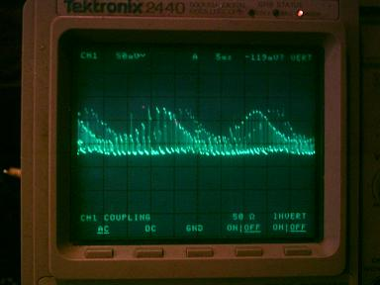

My prototype motor uses four of these circuit's around the rotor all in parallel. You can use just one read switch to switch all four transistors and coils but it is more load and the reed switch does not hold up for very long. In fact, either way, if you use small reed switched like these, they will get worn and start to stick. I have bought larger reed switched but I am also working on an electronic switching version of this, but this is easier said then done. I have worked on this for a few months now so I have tried very may things and have not matched it with electronic switching yet! Limiting current through the reed does not necessary increase it's longevity and produces less radiant energy.

Now having showed you all this, we are only half way to a complete radiant energy system that will provide continuous free energy. The above circuit and motor, even though provides copious amounts of radiant energy, will still only give you a COP equal to or close to one when performing battery swapping from source battery to charging battery. For battery swapping to work, you MUST have the second and equally important side to the system. The second side of the system is the radiant energy accumulator-converter.

A Working Radiant Free Energy System Part 2 - By Ossie Callanan

Before I get into the radiant energy accumulator-converter, I just want to highlight how important it is to build and play with the circuit I described above. Only after adjusting and watching the input current and how the charging battery charges can you truly see how these radiant energy pulses are affecting the charging battery. In terms of why it works or how it provides so much radiant energy you have to understand that if the reed switch stays closed, which will happen when they get worn and sticky, with the 9mH (bought off the shelf) crossover choke solenoid coil I use, the transistor is turned fully on and at virtually it's lowest resistance and so the current draw is about 6-8 AMPS for a single coil circuit!!! It seems this is a key requirement for generating these radiant energy pulses with a transistor. You have to switch the transistor fully on at maximum current for the coil and input voltage. This is another thing the SSG does not do well. But yet, in this circuit, when the reed switch is adjusted correctly, you can get the input down to just a few milliamps if you want!

OK, now to the radiant accumulator-converter. The requirement for this appears to be because the charging battery is not very efficient at absorbing all of the radiant energy pulses. John had related this as being due to impedance matching but I am not sure of this at this stage but impedance may be a factor. Because the charging battery does not absorb much of the radiant energy by itself, you MUST have an accumulator-converter to absorb and convert the radiant energy for the charging battery to use. Ok, that said, what is a radiant energy accumulator-converter?

A Radiant Energy Accumulator-Converter (REAC) is nothing more than a dipole! But the larger the dipole the better! The dipole can be a battery but that is silly when we are already charging a battery. Well in that case, it is a special battery. It is a battery that is mostly composed of potential but little current. The higher the potential the better the accumulation/conversion but some current is still required to be able to pass the energy back and charge the charging battery.

There are a number of traditional dipole's that fit what is needed. There is a simple long and raised wire antenna and ground, but this will not provide enough back current to charge our battery. There is an earth battery setup, but unless you want to put in the effort and amount of materials to raise the voltage and still have some required current this requires a lot of work and materials. Finally, I found the best compromise to be "old, dead, sulphated lead acid batteries". At this stage of my research the condition of the battery does not really matter as long as it is dead and sulphated. As long as they are old and dead such that they can barely light up a 12V 100ma light bulb, they will do just fine. Gee I am glad I never threw away my old dead batteries that kept piling up.

Go down to a battery recycler or junk yard and you can buy pallet loads of old and dead UPS batteries for only a few dollars. When I say pallet load, I mean pallet load. The bigger the bank of these you get the batter. Connect them both in series and parallel such that if they where good, you would get anywhere from 48-120 volts. When connecting in parallel make sure that each 12 volt segment has an approximately even capacity in A/Hs. You can put this bank under your house or table or even bury them in the ground. It is no problem as you will never have to do anything to them again (as long as they are sealed)... They will NOT keep running down. They are already run down; all you need them for is to use their potential and their dipole and their hidden capacity. The very small amount of current they will provide for the size of the bank due to the crystalline resistance of the sulfation is all that is needed to provide the free energy that the will convert the radiant energy pulses and feed it back into your good charging battery. I believe that these sulphate crystals may indeed be the main component that is doing the radiant energy conversion for us. Now for how to connect up your REAC. See the following diagram.

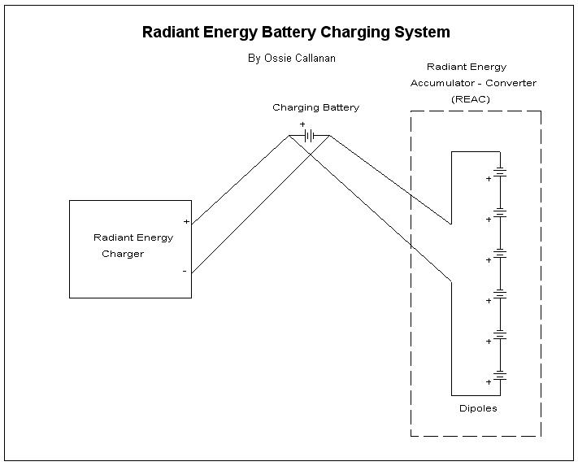

You must connect the REAC directly to the charging battery as I have shown above. Amazingly, there is a great voltage different when you measure the voltage directly across the charging battery compared to the voltage measured across the REAC whilst the reed motor is running. This is even with thick cables connecting them but distance does affect it as well. You must have two separate sets of cables. One set going directly from the radiant energy charger to the charging battery and the other set from the charging battery to the REAC.

I have run the above setup for over one month now. Following is a picture of my dead batteries that I use as an REAC.

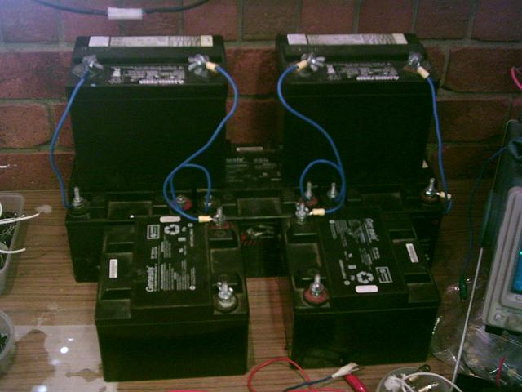

Using my good 33 A/H UPS batteries, I can charge them up from 10 volts to 14 volts in about 6 hours with the radiant energy reed motor running 4 coils drawing only 600ma. I can then swap the source battery with the charging battery and keep doing this until I have both batteries charged in about 24 hours. I have done this very many times and it appears to be improving over time.

But one thing I want to make clear if you think that I am somehow just using the stored energy in the REAC bank. If I do not use my reed motor, then the charging battery will not charge. If I try replacing the reed motor with a regular battery charger, the battery will take as long to charge as a normal battery charger would to charge it. When using the reed motor, the REAC is converting most of the radiant energy and providing the energy back to the charging battery. There you have it, a fully working radiant free energy system. Enjoy!

Regards,

Ossie Callanan

